CONTINUOUS EMISSION MONITORING SYSTEM MRU SWG 300⁻¹
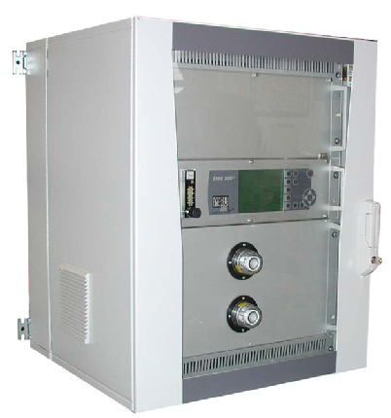
emission level of flue gas at different type of combustion.
The following components can be measured and indicated:
O2 Oxygen 0 – 25,0 % electrochemical cell
CO2 Carbon dioxide 0 – 20,0 % NDIR technology
CO Carbon monoxide 0 – 200 ppm NDIR technology
SO2 Sulphur dioxide 0 – 200 ppm NDIR technology
NO Nitric monoxide 0 – 200 ppm NDIR technology
NO2 Nitric dioxide 0 – 200 ppm catalytic conversion into NO

SHORT DESCRIPTION
• The continuous emission analysis is based on non dispersive infrared technology for toxic gas analysis.
The built-in NDIR benches of the SWG 300-1 analyze the gases without cross interferences.
• The oxygen analysis is performed by means of long-life (estimated 5 years life time) electrochemical cell
or by means of ZrO2 sensor or paramagnetic cell (please choose your option).
• The analyzer is prepared for O2 analysis and can be upgraded with up to 4 NDIR benches for each CO,
CO2, NO and SO2. The infrared benches for low measuring range CO, NO and SO2 are mounted in
individual 19” racks, 4U height.
• An optional external transmitter (4-20mA or 0-10Vdc type) can be connected to the AUX input connector.
• The SWG 300-1 should be installed nearly to the gas sampling points, so that there is only a short distance
between the analyzer and the gas sampling point. This will decrease the response time of analyzer. The
standard length of the heated sample line is 5 m ( longer sample line length , up to 20m is possible).
• The analyzer is equipped with a complete sample conditioning system mounted in a 19” rack, 6HE height.
The main control unit with display and operation keys is mounted in the same rack.
• The SWG 300-1 is equipped with a RS485 digital data interface and analog outputs as 8 channel 4-20mA
current loops. The measured data will be provided at these outputs and also at the RS485 interface. The
data will transfer measured data to the PC with MRU data logging and visualization software.
• Display for analysis data and service data indication are direct in front of the SWG 300-1.
• The SWG 300-1 is designed for continuous measurement. The automatic zero calibration is occurring at
least once a day according to the free user software settings. Fresh ambient air is used as zero calibration
gas.
• By means of inlets at the bottom of the enclosure, the installation of the power supply 115V or 230V /
50Hz / 60Hz, the gas sampling line, the condensate outlet and the data lines are carried out.
• The place of installation SWG 300-1 has to be in a dry, weatherproof ambient with temperature between
+5°C and +40°C. For higher ambient temperatures, the option “air conditioning” is mandatory. This option
is possible only for cabinets with 15HE and 21HE and must be ordered with the analysis system. Later
order and mounting of air conditioning system is not possible.

HARDWARE
The complete hardware is mounted into a steel cabinet with glass front door.
(weight approx. 90 kg, protection IP 54, with 4 fastening loops for wall mounting).
Steel cabinet height (9U, 15U or 21U) will be adapted to the total measuring requirement.
- Lockable glass door
- Ventilation through the cabinet (not at air conditioning)
- Local operation keyboard and back lighted LCD display for indication of measured data
- Complete flue gas conditioning system with:
  - Gas sampling pump
  - Sample gas cooler
  - Automatic condensate draining
  - Filter elements for flue gas and ambient air
  - Flow indication and surveillance
  - Solenoid valve for auto-zero and calibration
- Main ∝-processor board
- Sensors and amplifier electronics, infrared benches are mounted in individual 19” racks
- RS485 interface
- 8x analog outputs as 4-20mA current loop
- power supply for external transmitter
SOFTWARE
Standard software for all aforementioned functions with self-check of all internal functions:
• System diagnosis
• Gas cooler automatic control
• Sensor functions
• Condensate monitoring
• Automatic and standby operation
• Automatic control of solenoid valve for auto-zeroing and calibration
• Automatic control of solenoid valve for probe back-purge
• Temperature control and regulation of heated sample line and heated filter
• Digital data transmission, including PC visualization software
• Data logging of external transmitter

TECHNICAL DATA
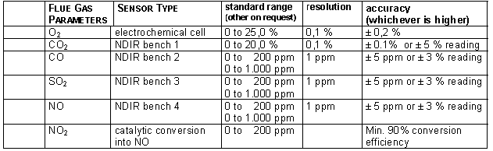

Calculated values: [mg/m3]; NOx as NO2 [mg/m3]; [mg/m3 referenced to xx%O2]
Response time: 20 seconds from analyzer sample inlet port
Display: full function graphic LCD display with backlight
Sample gas conditioning: integrated gas cooler with dew point = +5°C, filtering particle size < 1 µ
Ambient temperature: +5°C to + 40°C, relative humidity of air max. 95 %, non condensing
Enclosure:
9U: 478 x 600 x 575mm (H x W x D)
15U: 746 x 600 x 575mm (H x W x D)
21U: 1012 x 600 x 575mm (H x W x D)
Weight: approx. 90 kg
Type of protection: IP 54
Power supply: 230Vac, 50 Hz, up to 600W for heated sample line temperature control
Other power supply on request
Output signals: 8 x analog output, 4 to 20mA, RS485 digital data transmission
(including PC software MRU 32-bit Data Logger)

Gas sampling probe LD, with in-situ filter

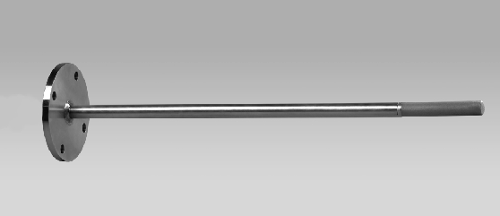

Gas sampling probe for applications with low dust rate, with:
• Stainless steel probe tube length ∅ 22 mm x 250/500/750/1000 mm,
or longer up to max. 2000 mm, for flue gas temperatures up to 500°C
• Inconel steel probe tube length ∅ 22 mm x 500/750/1000 mm,
or longer up to max. 2000 mm, for flue gas temperatures up to 900°C
• Stainless steel 1.4571 (SS316Ti) flange DN65 PN6
• In-situ sintered metal filter 3 um, screwable,
pipe connection for Teflon gas sample line DN6/4
with Teflon gas sample line DN6/4, 10 m
Option:
• Heated gas sample line with:
o exchangeable Teflon hose (PTFE), DN6/4
o 230Vac, 100 W/m
o length 5 m (for other length see price/meter)

Gas sampling probe HD, with heated filter
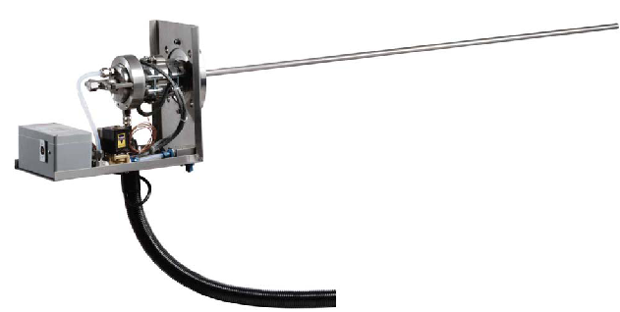
Gas sampling probe for applications with high dust rate, with:
• Stainless steel probe tube ∅ 22 mm x length 250/500/750/1000 mm,
or longer up to max. 2000 mm, for flue gas temperature up to 600°C
• Inconel steel probe tube ∅ 22 mm x length 500/750/1000 mm,
or longer up to max. 2000 mm, for flue gas temperature up to 1100°C
• Ceramic probe tube ∅ 22 mm x length 750/1000 mm,
or longer up to max. 2000 mm, for flue gas temperature up to 1700°C
• Stainless steel flange DN65 PN6
• Heated ceramic filter to approx. 150 °C, easy access for maintenance
• Automatic back purging with oil and water free compressed air, connection 6...10 bar,
• Pipe connection for heated sample line
• Protection cover against the hot surface of the filter
Option:
• Heated gas sample line with:
exchangeable Teflon hose (PTFE), DN6/4
230Vac, 100 W/m
length 5 m (for other length see price/meter)

